# Artificial Neural Networks

**Instructions:**

Please share your answers filled in-line in the word document. Submit code separately wherever applicable.

Please ensure you update all the details:

**Name: Biswajeet Padhi Batch ID: 280921**

**Topic: Artificial Neural Networks**

**Grading Guidelines:**

**1. An assignment submission is considered complete only when correct and executable code(s) are submitted along with the documentation explaining the method and results. Failing to submit either of those will be considered an invalid submission and will not be considered for evaluation.**

**2. Assignments submitted after the deadline will affect your grades.**

**Grading:**

|  |  |  |  |  |  |
| --- | --- | --- | --- | --- | --- |
| **Ans** | **Date** |  |  | **Ans** | **Date** |
| Correct | On time | A | 100 |  |  |
| 80% & above | On time | B | 85 | Correct | Late |
| 50% & above | On time | C | 75 | 80% & above | Late |
| 50% & below | On time | D | 65 | 50% & above | Late |
|  |  | E | 55 | 50% & below |  |
| Copied/No Submission |  | F | 45 |  |  |

* **Grade A: (>= 90):** When all assignments are submitted on or before the given deadline.
* **Grade B: (>= 80 and < 90):** 
  + When assignments are submitted on time but less than 80% of problems are completed.

(OR)

* + All assignments are submitted after the deadline.
* **Grade C: (>= 70 and < 80):** 
  + When assignments are submitted on time but less than 50% of the problems are completed.

(OR)

* + Less than 80% of problems in the assignments are submitted after the deadline.
* **Grade D: (>= 60 and < 70):**
  + Assignments submitted after the deadline and with 50% or less problems.
* **Grade E: (>= 50 and < 60):** 
  + Less than 30% of problems in the assignments are submitted after the deadline.

(OR)

* + Less than 30% of problems in the assignments are submitted before the deadline.
* **Grade F: (< 50):** No submission (or) malpractice.

**Hints:**

1. **Business Problem**
   1. **What is the business objective?**
   2. **Are there any constraints?**
2. **Work on each feature of the dataset to create a data dictionary as displayed in the below image:**

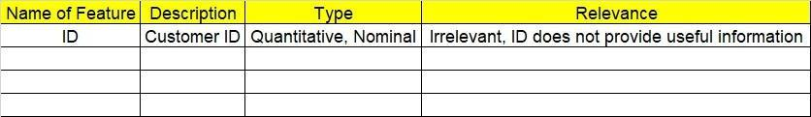

**2.1 Make a table as shown above and provide information about the features such as its data type and its relevance to the model building. And if not relevant, provide reasons and a description of the feature.**

1. **Data Pre-processing**

**3.1 Data Cleaning, Feature Engineering, etc.**

**3.2 Outlier Treatment if applicable.**

1. **Exploratory Data Analysis (EDA):**
   1. **Summary.**
   2. **Univariate analysis.**
   3. **Bivariate analysis.**
2. **Model Building:**
   1. **Build an Artificial Neural Network model on the given datasets.**
   2. **Use TensorFlow and Keras packages.**
   3. **Briefly explain the output in the documentation for each step in your own words.**
   4. **Use different activation functions to get the best model.**
3. **Write about the benefits/impact of the solution - in what way does the business (client) benefit from the solution provided?**

1. We have a dataset which contains the details of 50 startups. Build an ANN model to predict the profit of a new startup based on certain features.

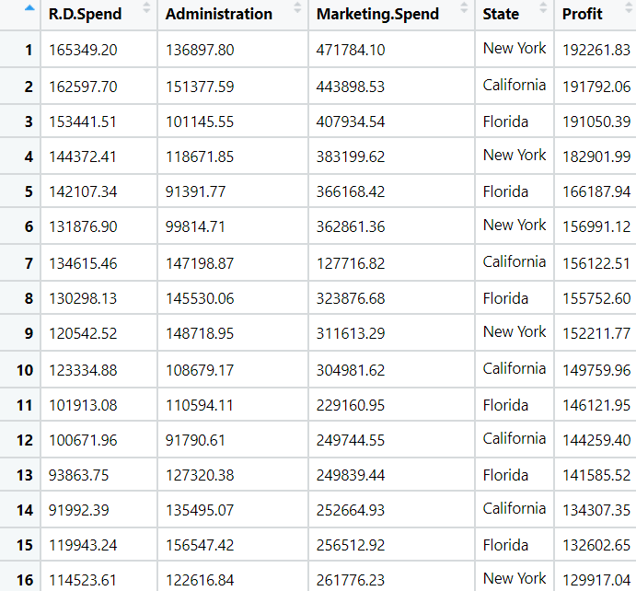



1. We have a dataset about 517 fires from the Montesano natural park in Portugal. For each incident, weekday, month, coordinates, and the burnt area are recorded, as well as several meteorological data such as rain, temperature, humidity, and wind. Predict the burnt area of forest fires with the help of an Artificial Neural Network model.

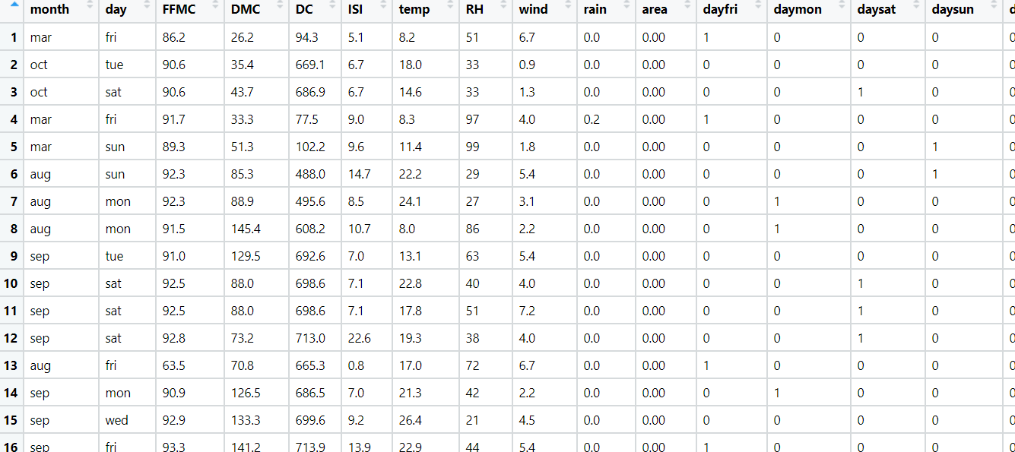

1. The following dataset consists of 1030 instances with 9 attributes and has no missing values. There are 8 input variables and 1 output variable. Seven input variables represent the amount of raw material (measured in kg/m³) and one represents Age (in Days). The target variable is Concrete Compressive Strength measured in (Mega Pascal). Build a Neural network model to predict the compressive strength.

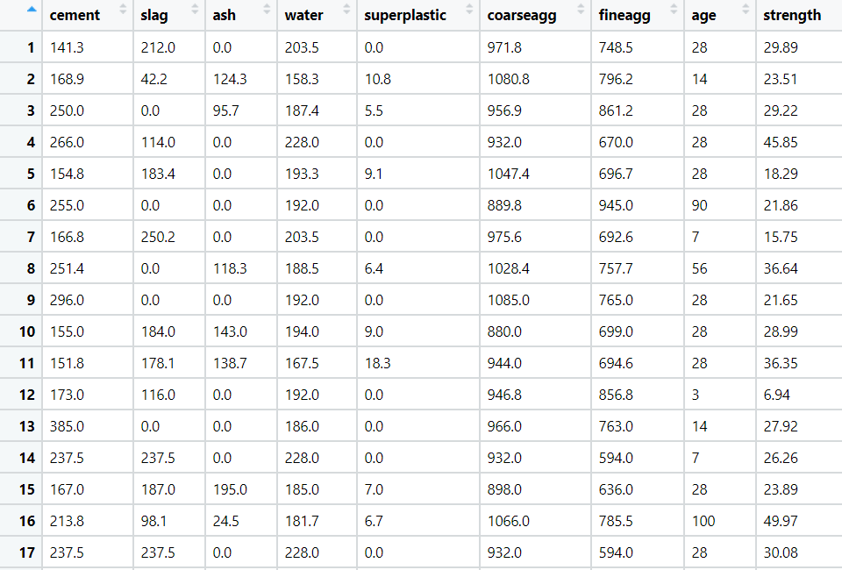

1. RPL Banking and Financing company wants to study the behavior patterns of their customers so that they can efficiently provide their services and solve the problem of churn. They have historical data of their customers. Build an Artificial Neural Network with Exited as the target variable.

